Editor in chief – Revista Brasileira de Atividade Física e Saúde
November 5 th, 2015
We have prepared an article entitled “Physical capacity in community-dwelling elderly with and without acute low back pain. BACE Study.” to be published by Revista Brasileira de Atividade Física e Saúde. The paper was edited by the Editage to ensure that the English language is clear and free of errors.
This article should be included in section Original Article.
Potential contribution of the study for development of physical activity and health area: Low back pain (LBP) is a complaint of great importance among the elderly due to its significant impact on function. However, the effect of acute LBP on the physical capacity of older patients is not well known. To our knowledge, there is not other study that examined brazillian elderly with and without acute LBP with a battery of functional tests. A better understanding of the physical capacity of the elderly with LBP may contribute to a better comprehension of the health-disease process experienced by LBP patients, allowing health professionals to formulate therapeutic problems and objectives according to the specific functional profile of each individual.
The content has not been published elsewhere.
The protocol for the research project has been approved by a suitably constituted Ethics Committee of the institution (Ethics and Research Committee of the Federal University of Minas Gerais for the Opinion nº ETIC 0100.0.203.000-11) within which the work was under­taken and that it conforms to the provisions of the Declaration of Helsinki (as revised in Seoul 2008).
The subjects gave informed consent and patient anonymity will be preserved.
All authors have contributed significantly and that all authors are in agreement with the content of the manuscript.
This paper was supported by FAPEMIG, CNPq, CAPES and Pró-Reitoria de Pesquisa da UFMG. The authors declare no potential conflicts of interest.
We hope that this manuscript could be suitable for publication in Revista Brasileira de Atividade Física e Saúde.
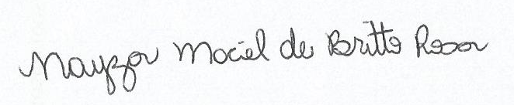
Nayza Maciel de Britto Rosa
Departamento de Fisioterapia - Universidade Federal de Minas Gerais / UFMG
Av. Antônio Carlos, 6627, 31270-901, Belo Horizonte, MG, Brasil
Telephone: +55-31-3499-4783; Fax: +55-31-3499-4781;
E-mail: nayzabritto@yahoo.com.br

