Author’s agreement

Manuscript title:
Barriers for Physical Activity in overweight adults
The authors herein signed, state that:

- This manuscript is an original work, has not been previously published nor is being simultaneously submitted elsewhere;
- The authors agree that the manuscript Will be under review for publication in Motriz;
- If the study includes participation of human beings or animals, please fill out the compliance/assessment by an ethics committee:

This study complies with the ethics committee of (state the name of the institution): Universidade Estadual de Ponta Grossa – 152/2011
Approval date: Dezembro de 2011
Approval number: 152
Authors signatures:

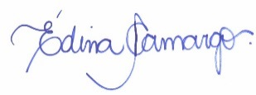
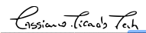
________________________________ ________________________________
Dr. Cassiano R. Rech Me.Edina Maria de Camargo
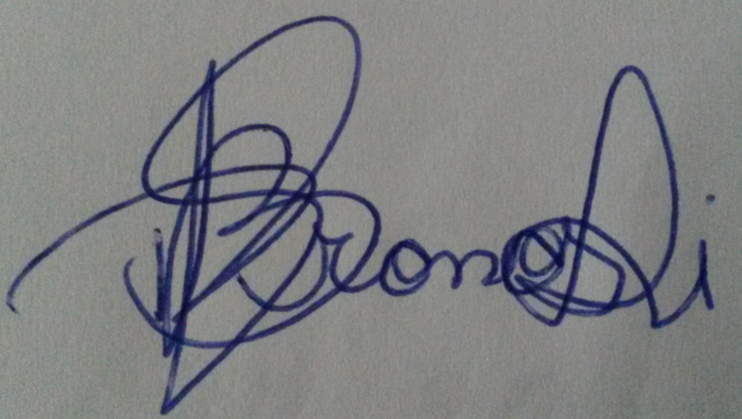
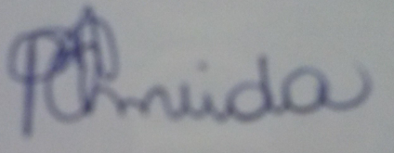
________________________________ _________________________________
Milena P.Almeida Renata dos S. Bronoski
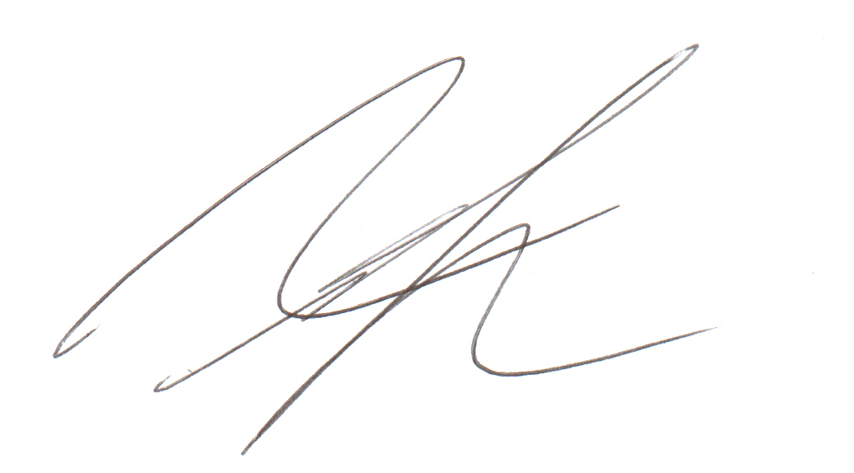
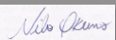
________________________________ ________________________________
Dr. Nilo Okuno Dr. Rodrigo S. Reis

